Data Sheet: Pad Ready 14 Acre Site, Amherst VA
Address: Amelon Commerce Center, 200 East Progress Lane, Madison Heights, VA 24572

This 14.6 acres site was graded in October 2017 into an 8.1 pad ready site that can accommodate a 109,000 SF building. The price of lot can be reduced based on new investment and jobs.
Total Site Acreage: 14.6
Graded Site Acreage: 8.1
Zoning: M-1 Industrial
Due Diligence completed in 2017:
Phase I Environmental Site Assessment, Geotechnical,Endangered/Threatened Species Review
Owner: Economic Development Authority of Amherst County
Utilities:
- 3-Phase Power: Appalachian Power (AEP)
- Water/Sewer: Municipal - Amherst County Service Authority
- Telecommunications: Comcast Business
Access to Highways: 4-lane connector road to highway US 29 (2 miles), US 460, I-64, I-81 nearby
Price: $277,000 *price is negotiable based on the type of company and projected jobs and investment

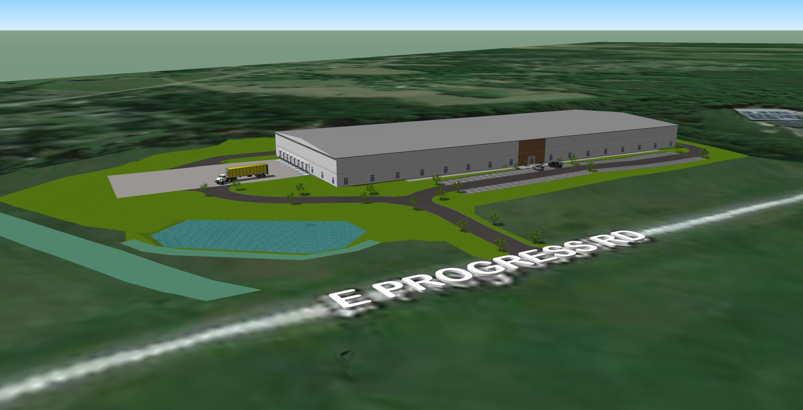
Other Companies in the Amelon Commerce Center: Quality Archery Design, England’s Stove Works, Integrated Technology Group, Old Dominion Footwear, H.S. Hutter Company
Nearby Companies in Amherst County:
- Jemison Metals (carbon flat-rolled products)
- Cooper Steel (steel fabricator)
- S&S Machine (machine shop) & Truball Archery (archery accessories)
- Commercial Steel Erection (engineered rigging and steel erection)
- Cowan Trucking (transportation)
Contact: Victoria Hanson, Amherst County Economic Development
434.946.5200 (Office) 434.260.4497 (Cell) www.amherstvabusiness.com

